Question 4:

Table 4.1. Analysis of variance in multiple variable regression.

H0:β1 = β2 = β3 = 0; Ha: At least one β ≠ 0. α = 0.05.

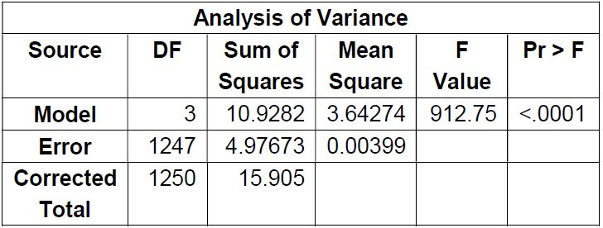∵P(>F) < .0001.

∴H0 is rejected. At least one β ≠ 0.

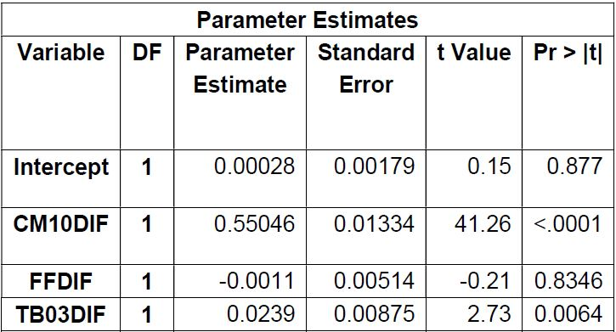Table 4.2. Parameter estimates in multiple variable regression.

H0: βi = 0; Ha: βi ≠ 0, for i = 1, 2, 3. Α = 0.05.

Hypotheses that intercept = 0, and that parameter of dif(FF) = 0, are not rejected. However, hypotheses that parameter of dif(CM10) = 0, and that parameter of dif(TB03) = 0, are rejected.

∴ parameters of dif(CM10), and of dif(TB03) ≠ 0.

Comparing global F-test and t-tests, there is no significant evidence of multicollinearity because non-zero parameters can be verified by non-zero single parameters.

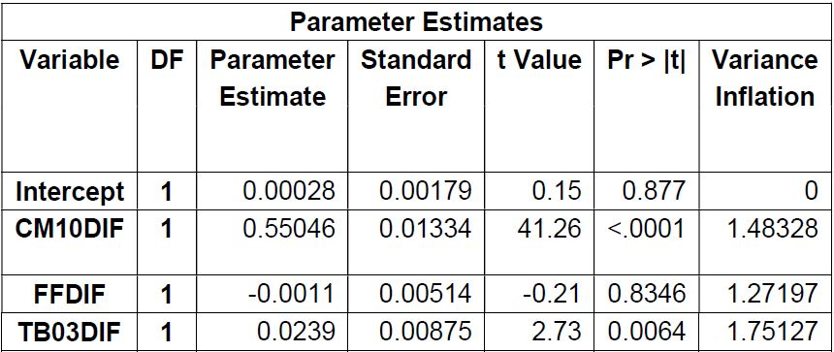Table 4.3. Variance inflation factors (VIF) analysis of parameters.

∵ VIFi << 10 , Ɐ i = 1, 2, 3.

∴ Multicollinearity cannot be detected, between any combination of the independent variables.

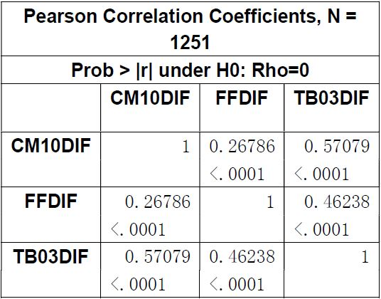Table 4.4. Correlation coefficients.

From the table, it is observed that all correlation coefficients ρ << .8, that is, all combinations do not have a high correlation.

∴ No multicollinearity can be observed.